Project Development Phase Sprint 1

|  |  |
| --- | --- |
| Date | November 2022 |
| Team ID | PNT2022TMID01380 |
| Project Name | Smart fashion recommender application |
| Maximum Marks | 4 Marks |

Registration Page:

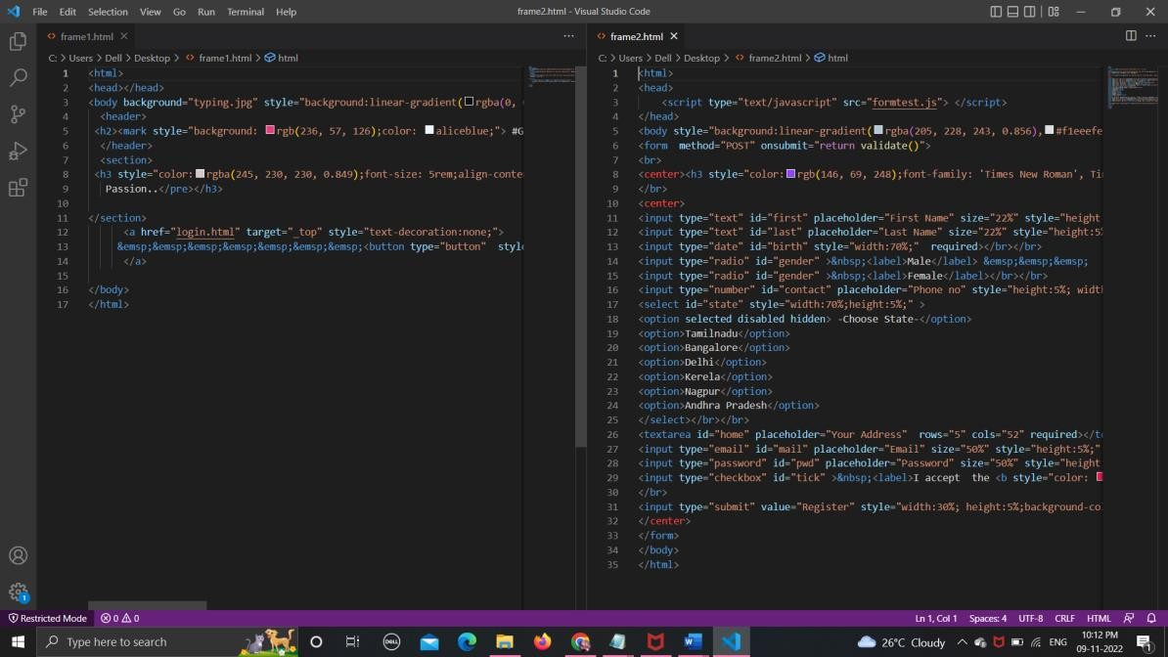

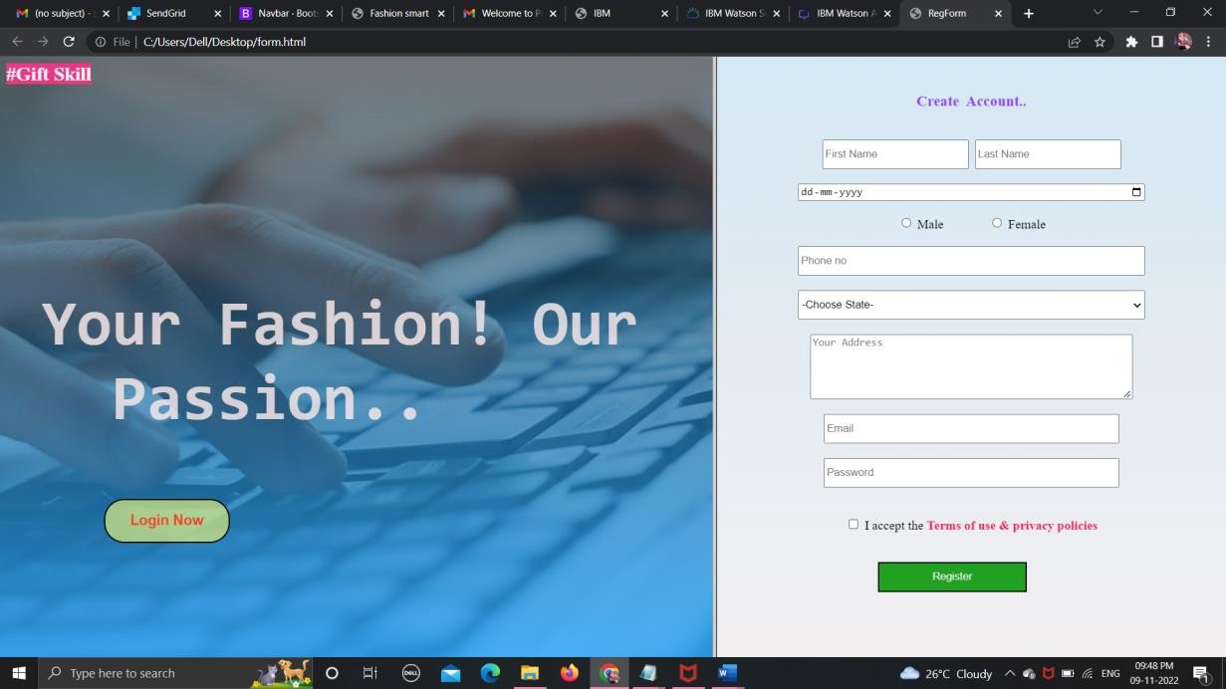

Login Page:

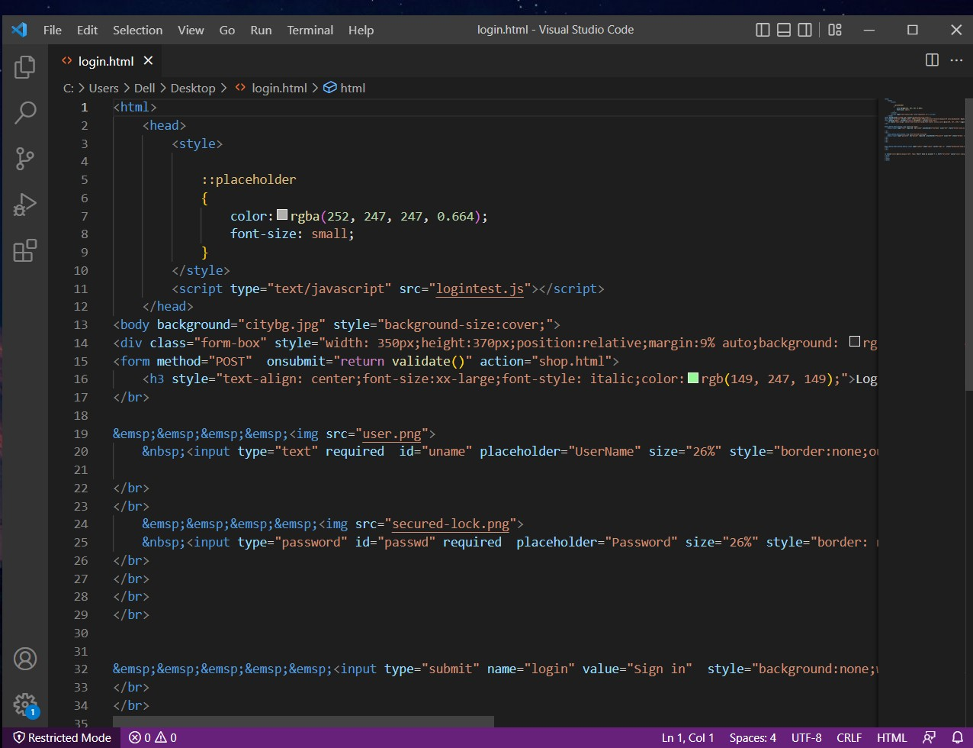

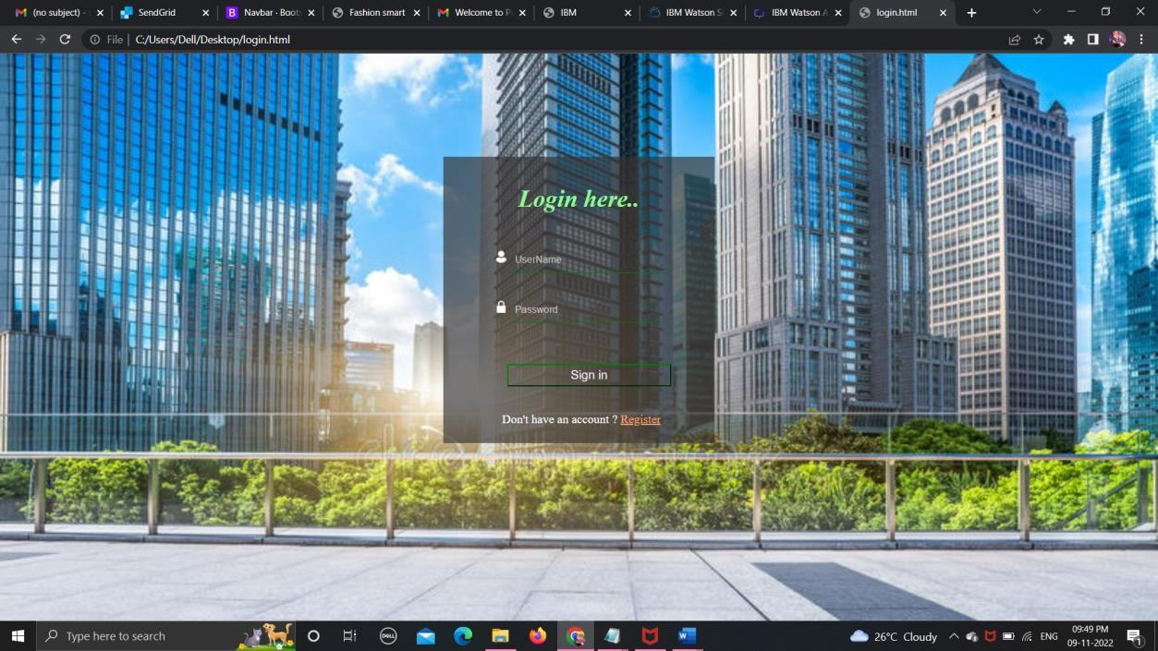

Product View Page:

